**Using the Ping sensor to measure distance**

The Hookup

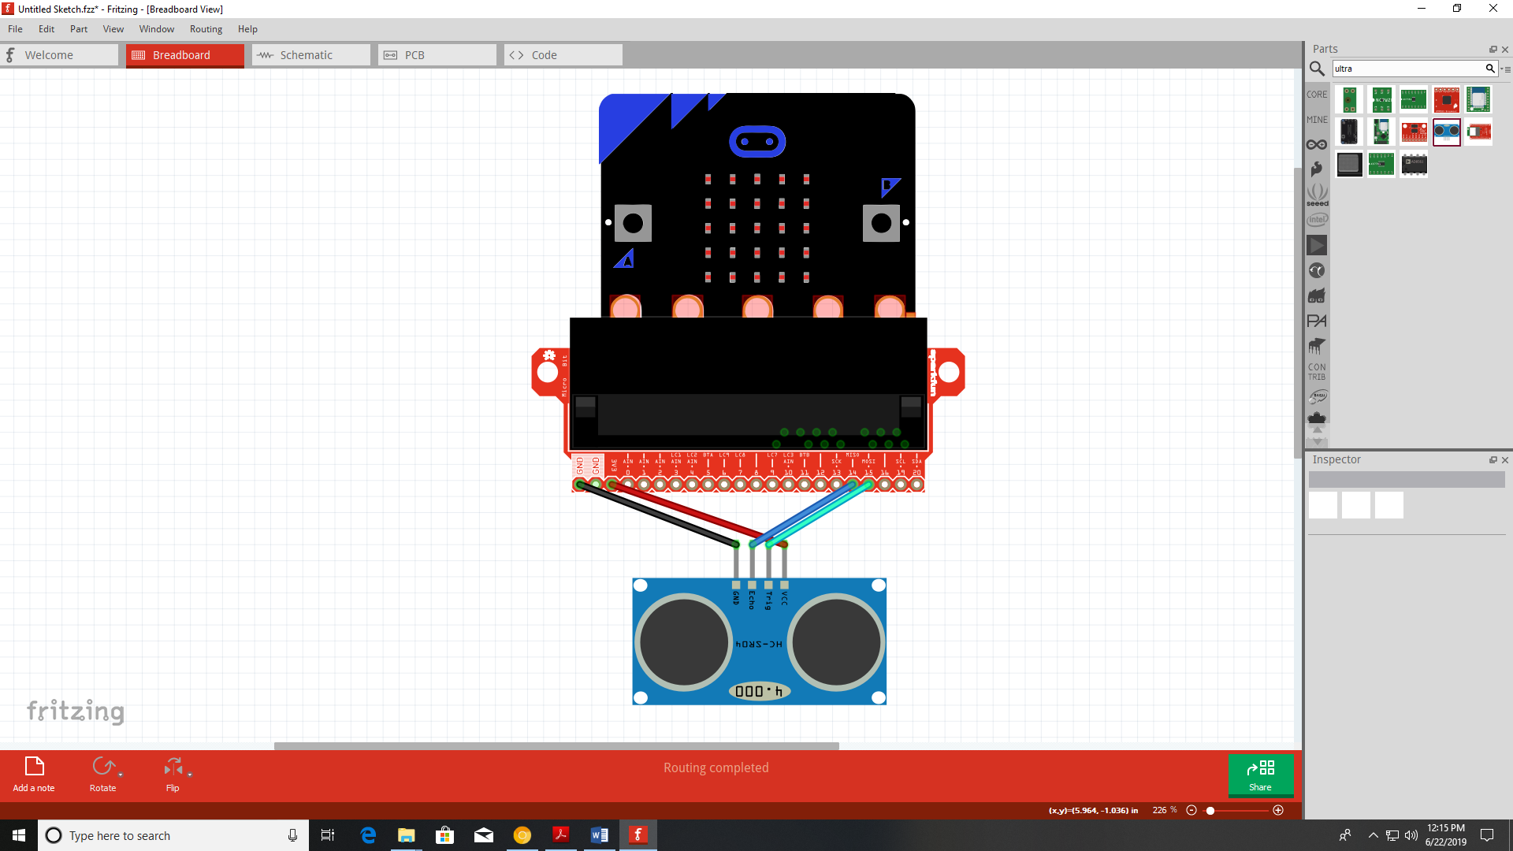

The Code

Make sure you have first added the Sonar Extension to MakeCode

Create a variable *distance*.

